SUBJECT: MATHEMATICS CLASS: SS 3

WEEK SCHEME OF WORK

- Theory of Logarithms: Laws of Logarithms and application of Logarithmic equations and indices
- Surds: Rational and Irrational numbers; basic operations with surds and conjugate of binomial surds
- Application of surds to trigonometrical ratios. Draw the graphs of sine and cosine for angles 00< x < 3600
- Matrices and Determinant: Types, order, Notation, basic operations, transpose, determinants of 2 x 2 and 3 x 3 matrices, Inverse of 2 x 2 matrix and application to simultaneous equation
- Linear and Quadratic Equations: Application, one linear-one quadratic, word problems leading to one linear-one quadratic
- Surface areas and volume of spheres and hemispheres (solid and hollow sphere and hemisphere)
- Longitude and Latitude: Identification of longitude and latitude, North and south, meridian, equator. Calculation of length of parallel of latitude.
- Longitude and Latitude: Calculation of distance between two points on the latitude, longitude, time or speed of aircraft
- Arithmetic Finance: Simple Interest, Compound Interest, Annuities, Depreciation and Amortization
- Revision of the term’s work

REFERENCE TEXTS:
  - New General Mathematics for SS book 3 by J.B Channon
  - Essential Mathematics for SS book 3
  - Mathematics Exam Focus
  - Waec and Jamb past Questions

WEEK 1
DATE:

THEORY OF LOGARITHMS AND LAWS OF LOGARITHMS
In general the logarithm of a number is the power to which the base must be raised in order to give that number. i.e if y=n^{x}, then x = logny. Thus, logarithms of a number to base ten is the power to which 10 is raised in order to give that number i.e if y =10^{x}, then x =log10y. With this definition log10100= 3 since 10³= 1000 and log10100 = 2 since 10²=100.
Examples:
- Express the following in logarithmic form
a) 2-6 = 1/64 b) 35 =243 c) 53 = 125 d) 104 = 10,000

Solutions
1. (a) 2-6 = 1

64
∴log2 (1/64) = -6 (b)35 = 243
∴ log3243 =5
(c)53 =125
∴ log5125 = 3
(d) 104 = 10,000
∴log1010000 = 4
- Express the following in index form
a) Log2(1/8) = -3 (b) Log10(1/1000) = -2 (c) Log464 (d) Log5625
(e) Log101000 Solutions
a) Log2 (1/8)= -3
Then 2-3 = 1/8
b) Log10(1/100) = -2 Then 10-2 = 1/100
- Let Log464 = k Then 4k = 64 Simplify 64; 4k = 43 Then k = 3
- Let Log5625 = m Then 5m = 625
5m = 54
m = 4
- Let Log101000 = p Then 10p = 1000
10p = 103
P = 3

Evaluation: Evaluate the following logarithms 1. Log48 2. Log6216 3. Log80.0625

Basic Laws of Logarithms
  - Log mn = Log m + Log n
  - Log (m/n) = Log m – Log n
  - Log mp = pLog m
  - Log 1 = 0

  - Logmm = 1
  - Log (1/m)n= Log m-n = -nLog m

Change of base
Log mn = Logan
Logam
Examples:
    - Express as logarithm of a single number 2Log3 + Log6 solution:
2log3 + log 6
= log32+ log 6 = log 9 + log 6
= Log 9 x6 = Log 54

    - Simplify Log 8 ÷ Log 4 Solution:
Log 8 ÷ log 4 = log 23 = 3log2 = 3/2
log 22 2log2
    - Evaluate 3log2 + log 20 – log 1.6 Solution
= log23 + log 20 – log(16/10)
= log 8 + log 20 – log (8/5)
= log (8 x 20÷ 8/5)
= log (8 x 20 x 5 ÷ 8)
= log 100 = log102 = 2log 10 = 2

Evaluation:
      - Simplify the following: a. ½ log 25 b. 1 + log 3 c. log 8 + log 4
      - Evaluate log 45 – log 9 + log 20
      - Given that log 2 = 0.3010, log 3 = 0.4771 and log 7 = 0.8451, evaluate a. log 42 b. log 35 4. Solve 22x - 10 x 2x+ 16 = 0

Further Application of Logarithms using tables:
Examples:
Use the tables to find the log of:
(a) 37 (b) 3900 to base ten Solutions
1. 37 = 3.7 x 10
=3.7 x 101(standard form)
=100.5682 + 1 x 101 (from table)
=101.5682
Hence log1037 = 1.5682 2. 3900 = 3.9 x 1000
=3.9 X 103 (standard form)
=100.5911 x 103 (from table)
=100.5911 + 3
=103.5911
Therefore log103900 = 3.5911

Evaluate the following using tables 1. 4627 x 29.3
2. 819.8 ÷ 3.905
3. 48.63 x8.53
15.39 x 3.52

Solutions

1.
4627 x 29.3
No Log
4627 3.6653
29.3 1.4669
135600 5.1322

4627 x 29.3 = 135600 (4 s.f)

2. 819.8 ÷ 3.905
No Log
819.8 2.9137
3.905 0.5916
209.9 2.3221

Therefore 819.8 ÷ 3.905 = 209.9

3. 48.63 x 8.53
15.39 x 3.52
r | No log
 | 48.63 1.68  8.53 0. | 69  9309
 | 2.61782.6 | 178
15.39 1.  2 0.5465 |  | 1872
inator1.7337 |  | 1.7337
0. |  | 8841

Numerato

3.5
Denom 7.658

Therefore 48.63 x 8.53 = 7.658
15.39 x 3.52

Evaluation
Use logarithms tables to calculate
1. 36.12 x 750.9 2. 319.63 x 12.282 x 74
113.2 x 9.98

General evaluation
- Change the following to logarithms form a. 25 ½ = 5 b. (0.01)2 = 0.0001
- Change the following to index form a. Log31 = 0 b. Log15225 =2
- Evaluate the following using logarithms tables a. 69.7 x 44.63
25.67
b. 17.9 x 3.576 x 98.14
c. (35.61)2 x 5.62
3√143.5
Reading assignment: NGM for SSS BK1 pg 18 – 22 and ex. 1c Nos 19 – 20 page 22

Weekend Assignment
1. Find the log of 802 to base 10 (use log tables) (a) 2.9042 (b) 3.9040 (c) 8.020 (d)1.9042
2. Find the number whose logarithm is 2.8321 (a) 6719.2 (b) 679.4 (c) 0.4620 (d) 67.92
3. What is the integer of the log of 0.000352 (a) 4 (b) 3 (c) 4 (d)3 4. Given that log2(1/64) = m, what is m ? (a) -5 (b) -4 (c) -6 (d) 3
5. Express the log in index form: log1010000 =4 (a) 10³ = 10000 (b) 10⁻⁴ = 10000 (c) 10⁴ = 10000
(d) 105 =100000

Theory
- Evaluate using logarithm table 6.28 x 304

981
and express your answer in the form A X 10n, where A is a number between1 and 10 and n is an integer.
- Use logarithm table to calculate 6354 x 6.243 correct to 3 s.f
16.76 x 0.0323

WEEK 2 DATE………………….
TOPIC: ADDITION, SUBTRACTION AND MULTIPLICATION OF SURD CONTENTS:

  - Definition of surd
  - Like surds
  - Simplification of surd
  - Addition and subtraction of surd
  - multiplication of surds

DEFINITION OF SURDS
A number which can be expressed as a quotient m/n of two integers, (n≠ 0) iscalled a rational number. Any real number which is not rational is called IRRATIONAL. Irrational numbers which are in the form of roots are called SURDS.

Examples:
, , π, , are all examples of irrational numbers.
2
3
5
m is taken to mean the positive square root of m and n 3 , is called a RADICAL.

LIKE SURD
What are like surds?
Two or more surds are like surds if the number under the square root sign is the same e.g

, 2 ,

, 3 and 6 are like surds.
3
3
3 4
2
2

SIMPLIFICATION OF SURD
Illustration
By putting m = 16 and n = 9, find which of the following pairs of expression are equal.

- and x
mn
m
n

- and +
m + n
m
n

- and
n
m
n
m
- and -

- 2 and
m − n
m
n
m
2m
- 3 and
n
9n

Solution
1.
16(9)
=

= 12
144

x = 4 x 3 = 12
16
9

2. = = 5
16 + 9
25

3. 4
16
9
=
3
+ 9 = 4 + 3 = 7

=
16
16
9
4
3

4. = = - = - 9 = 4 – 3 = 1
m − n
16 − 9
7
m
n
16
2

5. 2 =
m
16
2 = 2 x 4 = 8
= = or 4

6. 3 = 3 = 3 x 3 = 9 = = = 9
2m
2 ×16
32
n
9
9n
9 × 9
81

Solutions to question 1, 3, and 6 are equal.

Note:- The illustration demonstrates the fact that = x and =
mn
m
n
m n
m
n

To simplify surd where the square root sign as a product of the factor one of which should be a perfect square, then simplify the surd by taking the square root of the perfect square.

Example1
Simplify

(a)
45

Solution
(a) 45 =
(b)

9 × 5 =
150
(c) 3

x 5 = 3
15
9
3
25
6

(b) 150 =
25
3
3
25 × 6 =
x 6 = 5

(c)
3 75 = 3

25 × 3
= 3 x
x 3 = 3 x 5 x
= 15

Example 2
Express the following as a single surd
(1) 5 (2) 2
6
11

Solution
1. 5 = = =
6
5² ×6
25 × 6
150

2. 2 = = =
11
2² ×11
4x11
44

Evaluation:
- Simplify
  - b. c
20
63
147
- Express the following as a single surd.d. 4 e. 2
6
3

ADDITION AND SUBTRACTION OF SURDS
Two or more surds can be added together or subtracted from one another if they are like surds. Before addition or subtraction, the surds should first be simplified if possible.

Examples
Simplify:-

1. +
12
3
32
3. 2 − 3
8
2.
+ 4 4.
50
-
- + 2
3 5
32
7 5
27
75

Solution
1. +
12

2. 3 - 7

= 4 × 3 + 3 = (3 -7) 5
3
5
5
= 2 + = − 4
3
5
3
3
= (2+ 1) = 3
3

3. 2 - 3 + 4 5 0
8
32
= 2 4 × 2 - 3 + 4
16 × 2
25 × 2
2

= 2 × 2
2 - 3 × 4
2 + 4 × 5

= 4 - 12 + 20
= (4-12 + 20)
= 12 2
2
2
2
2
M4. R OSH3O2 /-M2A7T+HS2 /S75SS3/FIRST TERM Page 8
= - + 2
16 × 2
9 × 3
25 × 3
= 4 2 - 3 + 2 x 5
3
3
= 4 2 - 3 3 + 10 3

Evaluation:
Simplify the following
1. 2 - - 2 2. 3 - 18 3. 6 + +
150
96
24
2
27
75
- Simplify the following + 3 - 8
45
20
5
- Express as a single surd (i) 7√2 (ii) 8√7

MULTIPLICATION OF SURDS
When two or more surds are multiplied together, they should first be simplified if possible, then multiply whole number with whole number and surd with surd.

Examples:
Simplify  Solution |  | (1) |  | 27 x | 50 |  | (2) (4 3 )2(3) | 32 | x | 6 | x 2
(1) 27 | x | 50 |  |  |  | 2. | ( 4 3 )2

= 9x3 x

25 × 2
= 4 3 x 4

= 3 x 5 = (4 x 4)
3
2

(3)
= 3 x 5 x
= 15 x
3 × 2
6
= 15
6
x 6 x
32
2
= 16 x
= 16 x 3 = 48
3
3 × 3
9

= x x
16 × 2
6
2
= 4 x x
2
6
2

= 4 x
2 × 6 × 2
= 4 x
4 × 6

= 4 x 2
6
= 8
6

Evaluation:
Simplify:
30
12
60
45
3

- x x
5
24
- x 3 x
3. (2
)3 4. (2√5)3

5. (3√7 - √3)(3√7 + √3)

FURTHER EXAMPLES ON MULTIPLICATION OF SURDS
5
5
2
2

(1)

(3 + 2)(
+ 3)
(2) (3

− 2 3)(5
− 3)

Solution

(1)

(3 + 2)(
= 3 + 9
5
5
25

+ 3)
+ 2 + 6
5
5

= 3 × 5 + (9 + 2) + 6
5

= 15 + 6 + 11
5
= 21 + 11
5

(2)

(3 − 2
3)(5

− 3)

=15 − 3 − 10 + 2
2
2
4
6
6
9

= (15 × 2) − 3 − 10(

= 30 + 6 − 13
6
= 36 − 13
6

6) + (2 × 3)

Evaluation: Simplify: 1. (5√6 – 3)(5√6 + 3) 2. (7√13 + √5)(7√13 + √5)

DIVISION OF SURDS (RATIONALIZATION)
- Division of Surd (Rationalization)
- Multiplication of Surd involving and conjugate of binomial surd.
- Expression with Surds

Examples
18
2
9
9
7
9
7
3
7

1. =
18
2
= = 3 2.

= = =
× 7 = 3 7

7 7
3
7

Note: When a fraction has Surd as the denomination, the Surd is rationalized.
To rationalize the denominator of a rational surd, means to rationalize denominator remove the square root sign from the denominator.

Two types are considered

(a) Monomial denominator
a
b
a
b
b
b
a
b
a
b
a
b
b
b

(i)
= × = ab b

(ii)

= = ×
= ab b

(iii)

(iv)
= ×

5 7 × 2 3
21
6
21
6
45 × 21

= 21
6
6
6

6 = 7 6
2

5 7 × 2 3
= 5 × 2 ×

7 × 3 = 10

9 × 5 × 7 × 3

3 × 5 ×
7 × 3 3 5

10 × = 10 5 = 2 5
5
5
3 5 3 × 5 3

EVALUATION
2
3
2
4
8
12
24 − 6
18 × 20 × 24
8 × 30

(1)

2 − +
(2)
(3)

BINOMIAL DENOMINATOR:
Conjugate of a binominal surd
When an expression contains two terms e.g. 6 −
surd, it is known as BINOMINAL SURD.

5, 3 +

3, 2 + 4
2
3

and one or both of them contains

To rationalize binominal surd, multiply it by its conjugate i.e change the sign of the denominator and use the result to multiply both the numerator and the denominator.
3
3

e.g.

2 − 4
is the Conjugate of

2 + 4
i.e. the sign between the terms is changed or reversed.

Example:
Simplify
(1) 6
2 2 − 1

Solution
6
2 2 − 1
(1) =

(2)

×
6
2 2 − 1
+ 1]
2 2 + 1
2 2 + 1

(3) ⎛ + 1 ⎞

⎝
2 5 + 3
5 3 − 3 5
2
2 ⎠
⎜
2
⎟

6 2
2
[
=
(2 − 1)(2 + 1)
2
2

= 12 2 + 6 = 12 2 + 6
(4 × 2) − 1 7

(2)

2 5 + 3
5 3 − 3 5

= 2 5 +

5 3 − 3
3 × 5

5 5
3 + 3 5

3 + 3 5

= 10

15 + 6
25

25 + 5
9 − 9

9 + 3 15
25

= (10 15 + 3
15 + (6 × 5) + (5 × 3)

= (10 + 3)
(25 × 3) − (9 × 5)

15 + 30 + 15

= 13

75 − 45
15 + 45

30

(3) ⎛ 1 ⎞
2
+
2
⎜
⎟

⎝ 2 ⎠
⎛ + 1 ⎞⎛ + 1 ⎞

2
2
= ⎜ ⎟⎜ ⎟
2 ⎠

⎝ 2 ⎠⎝
⎛ 2 + 1⎞⎛ 2 + 1⎞

= ⎜ ⎟⎜

⎝ 2 ⎠⎝
= 3 × 3
2
2
⎟

2 ⎠
9
= = 4 12

2

Evaluation: Rationalize the following 1. 2. 3.
2
3 + 1
5 3
4 3 − 3
7 − 3 2
2 7 − 3

EVALUATION OF EXPRESSION WITH SURDS:
When evaluating a fraction containing a surd, it is advisable to rationalize its denominator.

Example:
2
3

Given that Evaluate:
= 1.414 and
= 1.732

(1)
2
3

Solution
(2)

(1)

2 = 2 ×
3 3

3 = 2 3
3 3

(2)

= × = 10 2 = 5
2
10
2
10
2
10
2
2
2
2
12

2(1.732) = 3.464 = 1.154
5 = 5(1.414) = 7.070 ,
7.07(2d. p)

3 3

- Without using tables or calculator, evaluate:

Solution

=
+ 6 )

2 ⎛ 0.54 ⎞ + × 6
2 (
3
0.54
2
3

⎜ ⎟

⎝ ⎠
3
1
= +
2 × 0.8
2 × 2
= +
0.36
4

= 0.6 + 2

Evaluation
  - Given that
= 2.6

= 1.72,
3

= 1.414

  - Evaluate: (1) (2)
2
6
3
8
50 − 2

General Evaluation And Revision Questions
1. Evaluate √20 × (√5)3
2.√1.225 = 1.107, √12.25 =3.5 and √100 = 10. Evaluate √1225
  - Given that √2 = 1.414 , √3 =1.732 and √5 =2.236,without using tables or a calculator, evaluate the following to 2 d.p a. (√18 + √6 – 3) √2 b. √3 (√9 + 3 √27)
  - Calculate the altitude of of an equilateral triangle of side 12cm.Leave your answer in surd form. 5.The angle of depression of a boat from the top of a cliff 11 m high is 300.How far is the boat from the foot of the cliff ? Leave your answer in surd form.

6. Evaluate the following:
Simplify:
10
2
20
3
x ² y

1. 5 - 3 + 5 + 3 2.
12
18
72
75
x 3 x
3.(
)5 4.
5. 8√2 - 3√6 + √50

Reading Assignment:
- Essential Mathematics for SS 2 - by A. J. S. Oluwasanmi pages 25-35.
- Exam focus (Mathematics) By Ilori & Co

Weekend Assignment
19

- Evaluate: (
19
+ 11)(
− 11)

(a) 8 (b) 8 + 22

(c) 22 + (d)
19
19
19

- …………….is an example of Binominal Surd. (a) 3 (b) 3 + (c) (d) 3 + −
2
2
3
2
2
19

- Simplify:

4 18
8
7
5
35
7
5

(a) 3 (b) 3 (c) 6 (d) 12

- Rationalize 5

7 − 7 5
7 − 5
(a) − 2

(b)
35

4 − 6
- − (d)

4 − 8

- If
tan x =
1 , find Cos x – Sin x such that 0O = x ≤ 90O

3
2
3 − 1

(a)

3 + 1
2

(b)

(c)
2
3 + 1

3 − 1
2

(d)

THEORY
- Express 3√5 - √3 in the form a√15 +b, where a and b are rational numbers.

2√5 +3√3
2. Evaluate the following

3 ⎛ 12 ⎞
2
3
75
48 − 3

(a)

⎜ − ⎟
3 ⎝ 6 ⎠
(b)

.

WEEK 3 DATE………………………
Application of Surds to Trigonometrical Ratios Sine and Cosine graphs

  - Application of Surds to Trigonometrical Ratios: The following summary shows how to find the sine, cosine and tangent of angles in surd form.

Trigonometric ratios of 300 and 600:An equilateral triangle of side 2 units is used to obtain the values of sine, cosine and tangent of angles in surd form.

A 600

2 2

B 600 600 C

2
The triangle is divided into two by drawing a parallel line from A to BC, the resulting triangle is below:
A

300

MR OSHO/MATHS/SSS3/FIRST TERM Page 13

x 2

Applying the Pythagoras rule: Hyp2 = Opp2 + Adj2 22 = 12 + x2
4 – 1 = x2

B 600 C
1

x = √3
Hence; 300 : Sin 300 = ½, Cos 300 = √3/2, Tan 300 = 1/√3 600: Sin 600 = √3/2, Cos 600 = ½, Tan 600 = √3

Trigonometric ratios of 450:A right-angled isosceles triangle in ratio 1: √2: 1 is used to obtain the trigonometrical
ratios: A
450
1 m

m2 = 12 + 12
m = √2

B 450 C
1

Hence: 450: Sin 450 = 1/√2 or √2/2, Cos 450 = 1/√2 or √2/2, Tan 450 = 1

Examples:
Calculate the lengths marked x, y and z and give your in surd form.

D
A
z
x
y
600300
B 3cm C

To find x; using triangle ABC
Tan 600 = x
3
√3 = x

3
x = 3√3 cm
In triangle ABC; cos 600 = 3/z 1= 3
- z

In triangle ADC, sin 300 = x/y
1 = 3√3

z = 6cm

Evaluation:
2 y
y = 2 x 3√3 y = 6√3cm

Given the figure below A
300450

10cm

B C D

Calculate (a) |BC| (b) |CD| (c) |AD|

TRIGONOMETRICAL GRAPHS OF SINE AND COSINE OF ANGLES BETWEEN 00< θ < 3600

Sine θ Cosine

The figure above shows the development of (a) sine graph (b) cosine graph from a unit circle
Each circle has a radius of 1 unit. The angle θ that the radius OP makes with Ox changes as P moves on the circumference of the circles. Since P is the general point (x, y) and OP = 1 unit, then sin θ = y, Cos θ = x. Hence the values of x and y gives cos θ and sin θ respectively. These values are used to draw the corresponding sine and cosine curves. The following points should be noted on the graphs of sin θ and cos θ:

- All values of sin θ and cos θ lie between + 1 and – 1.
- The sine and cosine curves have the same wave shape but they start from different points. Sine θ starts from 0 while cosine θ starts from 1.
- Each curve is symmetrical about its crest(high point) and trough(low point). Hence, for the values of Sin θ and Cos θ there are usually two corresponding values of θ between 00 and 3600 for each of them except at the quarter turns, where sin θ and cos θ have values as given in the table below.
 | 00 | 900 | 1800 | 2700 | 3600
Sin θ | 0 | 1 | 0 | -1 | 0
Cos θ | 1 | 0 | -1 | 0 | 1

Evaluation:
- (a) Copy and complete the table below giving values of Sin θ correct to 2 decimal places corresponding to θ = 00, 120, 240, in intervals of 120 up to 3600. Use tables to find Sin θ.
- Using scales of 2cm to 600 on the θ axis and 10cm to 1 unit on the Sin θ axis, draw the graph of Sin θ.

- (a) Given the equation y = sin2θ – cosθ for 00 ≤ θ ≤ 1800, prepare the table of values for the equation (b)Using a scale of 2cm to 300 on the horizontal axis and 5cm to 1 unit on the vertical axis, draw the graph of y= sin2θ – cosθ for 00 ≤ θ ≤ 1800
- Use your graph to find: (i) the solution of the equation sin2θ – cosθ = 0, correct to the nearest degree.
- the maximum value of y, correct to 1 d.p

Reading Assignment: NGM for SS 3, Chapter 6, page 46 – 52 Weekend Assignment
- (a) Draw the graph of the equation y = 1 + cos 2x for 00 ≤ θ ≤ 3600 at interval of 300 Using a scale of 2cm to 300 on the horizontal axis and 2cm to 1 unit on the vertical axis
(b)Use your graph to solve 1 + cos 2x = 0

- Draw the graph of Sin 3θ for values of θ from 00 to 3600 using the appropriate scales.

WEEK 4 DATE…………………………….

MATRICES

*Definition of matrix and uses
*Examples and types of matrix

*Matrix addition and subtraction
*Multiplication of matrices

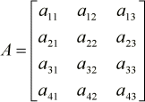
A matrix is an ordered set of numbers listed rectangular form. A matrix is, by definition, a rectangular array of numeric or algebraic quantities which are subject to mathematical operations. Matrices can be defined in terms of their dimensions (number of rows and columns). Let us take a look at a matrix with 4 rows and 3 columns (we denote it as a 4×3 matrix and call it A):
Each individual item in a matrix is called a cell, and can be denoted by the particular row and column it resides in. For instance, in matrix A, element a32 can be found where the 3rd row and the 2nd column intersect.Matrices and Determinants were discovered and developed in the eighteenth and nineteenth centuries. Initially, their development dealt with transformation of geometric objects and solution of systems of linear equations.
Historically, the early emphasis was on the determinant, not the matrix. In modern treatments of linear algebra, matrices are considered first. We will not speculate much on this issue.
Matrices provide a theoretically and practically useful way of approaching many types of problems including:

Here are a couple of examples of different types of matrices:

Symmetric | Diagonal | Upper Triangular | Lower Triangular | Zero | Identity

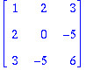 | 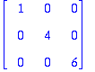 | 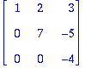 | 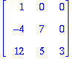 | 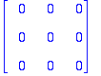 | 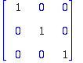

And a fully expanded m×n matrix A, would look like this:
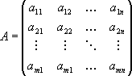

... or in a more compact form:
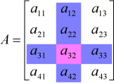
Example: Let A denote the matrix [2 5 7 8]
[5 6 8 9]
[3 9 0 1]

This matrix A has three rows and four columns. We say it is a 3 x 4 matrix.We denote the element on the second row and fourth column with a2,4.

Square matrix
If a matrix A has n rows and n columns then we say it's a square matrix. In a square matrix the elements ai,i , with i = 1,2,3,... , are called diagonal elements.
Remark: There is no difference between a 1 x 1 matrix and an ordinary number.

Diagonal matrix
A diagonal matrix is a square matrix with all de non-diagonal elements 0. The diagonal matrix is completely defined by the diagonal elements.

Example:

[7 0 0]
[0 5 0]
[0 0 6] The matrix is denoted by diagonal (7 , 5 , 6)
Row matrix :A matrix with one row is called a row matrix. [2 5 -1 5]
Column matrix:A matrix with one column is called a column matrix. [2]
[4]

[3]
[0]
Matrices of the same kind:Matrix A and B are of the same kind if and only if A has as many rows as B and A has as many columns as B
[7 1 2] [4 0 3]
[0 5 6] and [1 1 4]
[3 4 6] [8 6 2]

The transposed matrix of a matrix

The n x m matrix B is the transposed matrix of the m x n matrix A if and only if The ith row of A = the ith column of B for (i = 1,2,3,..m)
So ai,j = bj,I The transposed matrix of A is denoted T(A) or A^{T}

[7 1 ] [7 0 3]
[0 5 ] = [1 5 4]
[3 4 ]

0-matrix:When all the elements of a matrix A are 0, we call A a 0-matrix. We write shortly 0 for a 0-matrix.
An identity matrix (I):An identity matrix I is a diagonal matrix with all the diagonal elements = I.
A scalar matrix S :A scalar matrix S is a diagonal matrix whose diagonal elements all contain the same scalar value.
a1,1 = ai,i for (i = 1,2,3,..n)

[7 0 0]
[0 7 0]
[0 0 7]
The opposite matrix of a matrix: If we change the sign of all the elements of a matrix A, we have the opposite matrix -A.If A' is the opposite of A then ai,j' = -ai,j, for all i and j.
A symmetric matrix:A square matrix is called symmetric if it is equal to its transpose. Then ai,j = aj,i , for all i and j.
[7 1 5]
[1 3 0]
[5 0 7]
A skew-symmetric matrix :A square matrix is called skew-symmetric if it is equal to the opposite of its transpose.Then ai,j = -aj,i , for all i and j.
[ 0 1 -5]
[-1 0 0]
[ 5 0 0]

Matrix Addition and Subtraction
DEFINITION: Two matrices A and B can be added or subtracted if and only if their dimensions are the same (i.e. both matrices have the same number of rows and columns.

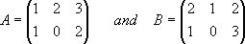
Take:
Addition

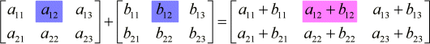
Addition and subtraction operations can easily be performed on matrices, provided the matrices have the same dimensions. All that is required is to add or subtract the corresponding cells of each matrix involved in the operation. Let us take a look at the addition of two 2×3 matrices, A and B:

If A and B above are matrices of the same type then the sum is found by adding the corresponding elements aij + bij .

Here is an example of adding A and B together.
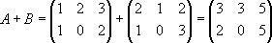

Evaluation:

1. Evaluate | -5 0 | | 6 -3 |
| | + | |
|_ 4 1 _| |_2 3_|

Subtraction of matrices is done in the same manner as addition. Always be aware of the negative signs and remember that a double negative is a positive!

SUBTRACTION

If A and B are matrices of the same type then the subtraction is found by subtracting the corresponding elements aij − bij.

Here is an example of subtracting matrices.
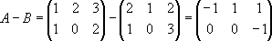

Example: Consider the three matrices J, F, and M from above. Evaluate

Answer. We have
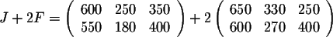

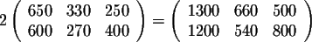
and since
we get
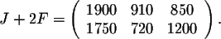

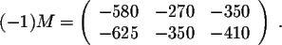
To compute J-M, we note first that Since J-M = J + (-1)M, we get
And finally, for J-F+2M, we have a choice. Here we would like to emphasize the fact that addition of matrices may involve more than one matrix. In this case, you may perform the calculations in any order. This is
called associativity of the operations. So first we will take care of -F and 2M to get
Since J-F+2M = J + (-1)F + 2M, we get
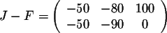
So first we will evaluate J-F to get
to which we add 2M, to finally obtain

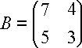Evaluation: Given 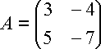 evaluate: 5A – 2B
MULTIPLICATION
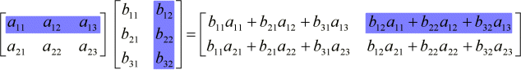
Performing the operation product involves multiplying the cells of a particular rows in the first matrix by the cells of a particular column in the second matrix, adding the products, and storing the result in the cell of the resultant matrix whose coordinates correspond to the row of the first matrix and the column of the second matrix. For instance, in AB = C, if we want to find the value of c12, we must multiply the cells of row 1 in the first matrix by the cells of column 2 in the second matrix and sum the results.

Example 1

Multiply:
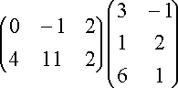

Answer

This is 2×3 times 3×2, which will give us a 2×2 answer.


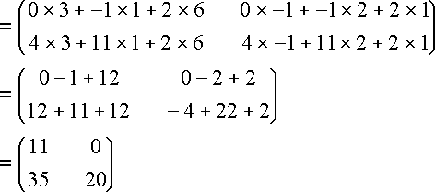

Our answer is a 2×2 matrix

Multiplying 2 × 2 Matrices

The process is the same for any size matrix. We multiply across rows of the first matrix and down columns of the second matrix, element by element. We then add the products:
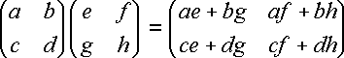

In this case, we multiply a 2 × 2 matrix by a 2 × 2 matrix and we get a 2 × 2 matrix as the result.

Example 2:

Multiply:
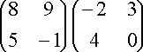

Answer
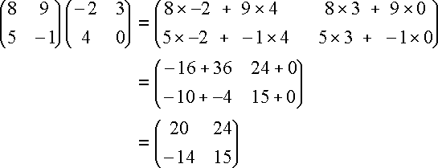

Note 2 : Commutativity of Matrix Multiplication:

Does AB = BA?

Let's see if it is true using an example

Example 3:

If

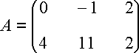
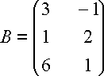
and

find AB and BA.

Answer

We performed AB above, and the answer was:
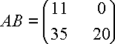

Now BA is (3 × 2)(2 × 3) which will give 3 × 3:
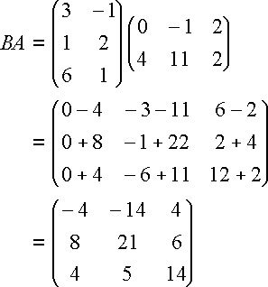

So in this case, AB does NOT equal BA

In general, when multiplying matrices, the commutative law doesn't hold, i.e. AB ≠ BA. There are two common exceptions to this:

- The identity matrix: IA = AI = A.
- The inverse of a matrix: A-1A = AA-1 = I.

Example 4 - Multiplying by the Identity Matrix

Given that
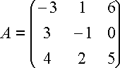

find AI. Answer

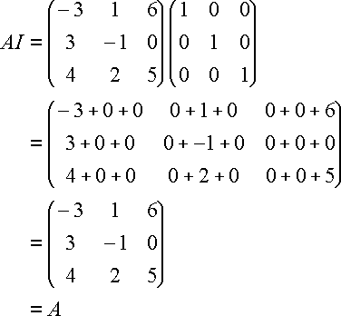

We see that multiplying by the identity matrix does not change the value of the original matrix.That is, AI = A

Further Examples Example1. If possible, find BA and AB.
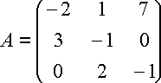

Answer
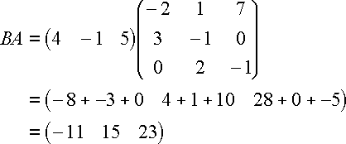

AB is not possible. (3 × 3) × (1 × 3).

Example2. Determine if B = A-1.



Answer

If B = A-1, then AB = I.
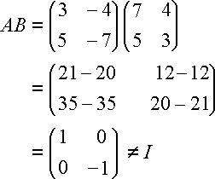

So B is NOT the inverse of A.

Example3. In studying the motion of electrons, one of the Pauli spin matrices is
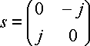

where

Show that s2 = I. [If you have never seen j before, it is on complex numbers].

Answer
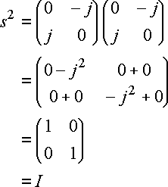

Example4. Evaluate the following matrix multiplication which is used in directing the motion of a robotic mechanism.
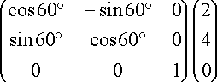

Answer
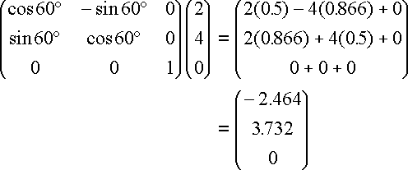

The interpretation of this is that the robot arm moves from position (2, 4, 0) to position (-2.46, 3.73, 0). That is, it moves in the x-y plane, but its height remains at z = 0. The 3 × 3 matrix containing sin and cos values tells it how many degrees to move.

TRANSPOSE AND INVERSE OF MATRICES, DETERMINANT OF MATRICES, APPLICATION OF DETERMINANTS

TRANSPOSE OF MATRICES

DEFINITION: The transpose of a matrix is found by exchanging rows for columns i.e. Matrix A = (aij) and the transpose of A is:

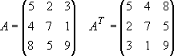
A^{T} = (aji) where j is the column number and i is the row number of matrix A. For example, the transpose of a matrix would be:

In the case of a square matrix (m = n), the transpose can be used to check if a matrix is symmetric. For a symmetric matrix A = AT.
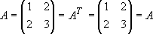

The Determinant of a Matrix

DEFINITION: Determinants play an important role in finding the inverse of a matrix and also in solving systems of linear equations. In the following we assume we have a square matrix (m = n). The determinant of a matrix A will be denoted by det(A) or |A|. Firstly the determinant of a 2×2 and 3×3 matrix will be introduced, then the n×n case will be shown.

Determinant of a 2×2 matrix

Assuming A is an arbitrary 2×2 matrix A, where the elements are given by:

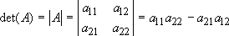
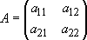 then the determinant of a this matrix is as follows:

Determinant of a 3×3 matrix

The determinant of a 3×3 matrix is a little more tricky and is found as follows (for this case assume A is an arbitrary 3×3 matrix A, where the elements are given below).
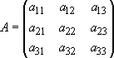

then the determinant of a this matrix is as follows:
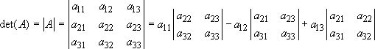

Determinant of a n×n matrix

For the general case, where A is an n×n matrix the determinant is given by:

Where the coefficients αij are given by the relation:

where βij is the determinant of the (n-1) × (n-1) matrix that is obtained by deleting row i and column j. This coefficient αij is also called the cofactor of aij.

Calculating a 2 × 2 Determinant

In general, we find the value of a 2 × 2 determinant with elements a, b, c, d as follows:
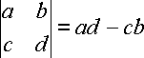

We multiply the diagonals (top left × bottom right first), then subtract.

Example 1
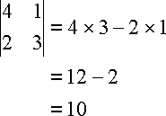

The final result is a single number.

Application of Determinants in Solve Systems of Equations

We can solve a system of equations using determinants, but it becomes very tedious for large systems. We will only do 2 × 2 and 3 × 3 systems using determinants.

Crammer's Rule

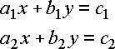
The solution (x, y) of the system

can be found using determinants:
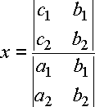
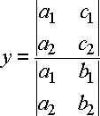

Example 2

Solve the system using Crammer's Rule:x − 3y = 6 ; 2x + 3y = 3

Answer

First we determine the values we will need for Cramer's Rule:

a1 = 1 b1 = -3 c1 = 6

a2 = 2 b2 = 3 c2 = 3
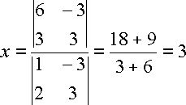
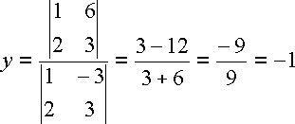

3 × 3 Determinants

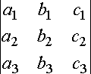
A 3 × 3 determinant

can be evaluated in various ways.

We will use the method called "expansion by minors". But first, we need a definition.

Cofactors

The 2 × 2 determinant

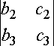 is called the cofactor of a1 for the 3 × 3 determinant:

The cofactor is formed from the elements that are not in the same row as a1 and not in the same column as a1.
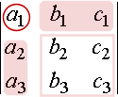

Similarly, the determinant

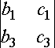

is called the cofactor of a2. It is formed from the elements not in the same row as a2and not in the same column as a2.

We continue the pattern for the cofactor of a3.

Expansion by Minors

We evaluate our 3 × 3 determinant using expansion by minors. This involves multiplying the elements in the first column of the determinant by the cofactors of those elements. We subtract the middle product and add the final product.
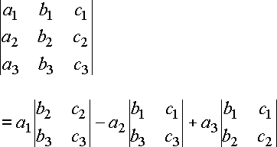

Note that we are working down the first column and multiplying by the cofactor of each element.

Example 3

Evaluate
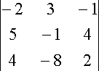

Answer
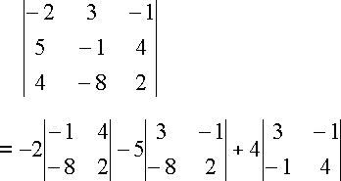

= -2[(-1)(2) − (-8)(4)] − 5[(3)(2) − (-8)(-1)] + 4[(3)(4) − (-1)(-1)]

= -2(30) − 5(-2) + 4(11)

= -60 + 10 + 44= -6

Here, we are expanding by the first column. We can do the expansion by using the first row and we will get the same result.

Crammer's Rule to Solve 3 × 3 Systems of Linear Equations

We can solve the general system of equations,

a1x + b1y + c1z = d1 a2x + b2y + c2z = d2
a3x + b3y + c3z = d3
By using the determinants:

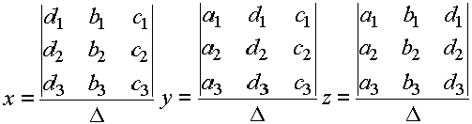 where
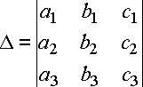

Example 4
Solve, using Crammer's Rule: 2x + 3y + z = 2
−x + 2y + 3z = −1
−3x − 3y + z = 0 Answer

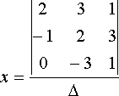
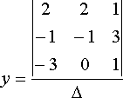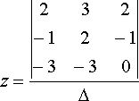

where
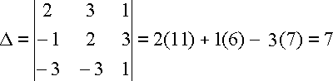

So
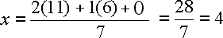
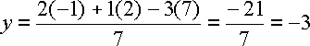

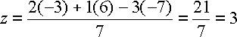

Evaluation

- Evaluate by expansion of minors:
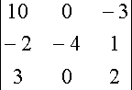

- Solve the system by use of determinants:

x + 3y + z = 4

2x − 6y − 3z = 10 4x − 9y + 3z = 4

The Inverse of a Matrix

DEFINITION: Assuming we have a square matrix A, which is non-singular (i.e. det(A) does not equal zero), then there exists an n×n matrix A-1 which is called the inverse of A, such that this property holds:

AA-1 = A-1A = I, where I is the identity matrix.

The inverse of a 2×2 matrix

Take for example an arbitrary 2×2 Matrix A whose determinant (ad − bc) is not equal to zero.
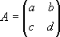

where a,b,c,d are numbers, The inverse is:
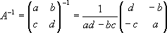

Now try finding the inverse of your own 2×2 matrices.

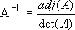
The inverse of a n×n matrix: The inverse of a general n×n matrix A can be found by using the following equation.

Where the adj(A) denotes the adjoint (or adjugate) of a matrix. It can be calculated by the following method:

- Given the n×n matrix A, define B = bij
to be the matrix whose coefficients are found by taking the determinant of the (n-1) × (n-1) matrix obtained by deleting the i^{th} row and j^{th} column of A. The terms of B (i.e. B = bij) are known as the cofactors of A.

- Define the matrix C, where
cij = (−1)i+j bij.
- The transpose of C (i.e. CT) is called the adjoint of matrix A.

Lastly to find the inverse of A divide the matrix CT by the determinant of A to give its inverse.

We'll find the inverse of a matrix using 2 different methods. You can decide which one to use depending on the situation.

The first method is limited to finding the inverse of 2 × 2 matrices. It involves the use of the determinant of a matrix which we saw earlier.

Reminder: We can only find the determinant of a square matrix. For example, if A is the square matrix

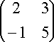 Then we can find the determinant of A:
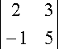 = 10 + 3 = 13.
For convenience, we could have written the determinant of A as |A| and so our final answer would be:

|A| = 13

Another way of writing the same thing is to use "det" for "determinant". So for example, in this case we would write: det(A) = 13

Method 1 - Transposing and Determinants

This method is only good for finding the inverse of a 2 × 2 matrix.

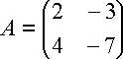
Example.

Find the inverse, A-1, of using Method 1. Answer
Method 1 is as follows. [1] Interchange leading diagonal elements:

-7 → 2; 2 → -7
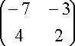

- Change signs of the other 2 elements:

-3 → 3; 4 → -4
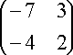

- Find the determinant |A|

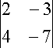 = -14 + 12 = -2

Multiply result of [2] by
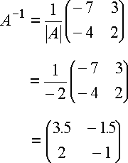

So we have found the inverse, as required.

Is it correct?

We check by multiplying our inverse by the original matrix. If we get the identity matrix (I) for our answer, then we must have the correct answer.
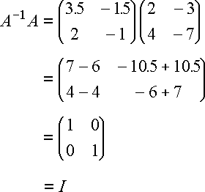

Method 2: Adjoint matrix

Method 2 uses the adjoint matrix method. Answer
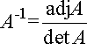
The inverse of a 3×3 matrix is given by:

"adj A" is short for "the adjoint of A". We use cofactors (that we met earlier) to determine the adjoint of a matrix.

Example: Consider the matrix
Cofactors Recall: The cofactor of an element in a matrix is the value obtained by evaluating the determinant formed by the elements not in that particular row or column.
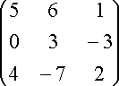

The cofactor of 6 is
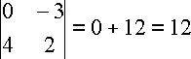

The cofactor of -3 is
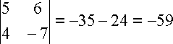

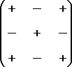
We find the adjoint matrix by replacing each element in the matrix with its cofactor and applying a + or - sign as follows:

and then finding the transpose of the resulting matrix. The transpose means the 1stcolumn becomes the 1st row; 2nd column becomes 2nd row, etc.

Example 1:

Find the inverse of the following by using the adjoint matrix method:

A =

Solution:

Step 1:

Replace elements with cofactors and apply + and -
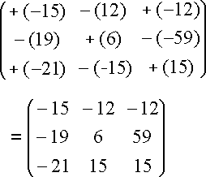

Step 2

Transpose the matrix:

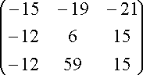
adjA =

Before we can find the inverse of matrix A, we need det A:
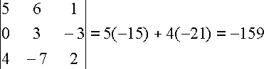

Now we have what we need to apply the formula



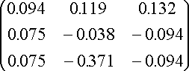
So, 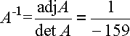

A-1 =

Example 2.
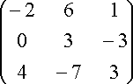
Find the inverse of

using method 2.

Answer
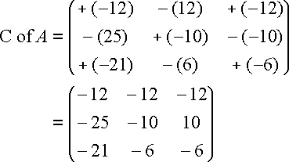

Interchange rows and columns:
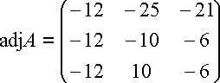

Det A = 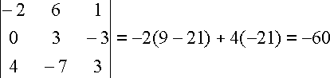 So

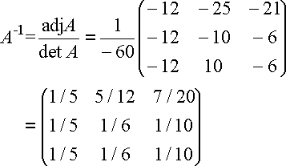

General Evaluation

  - Solve for x and y , x= ,y=

If X = and Y = , Find XY …………
  - Determine X + Y if 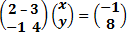
  - If 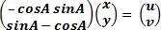, find u and v if x = 3, y = 1 and A =300 Reading Assignment: NGM for SS 3 Chapter 8 page 64

Weekend Assignment

- Find the non-zero positive value of x which satisfies the equation 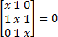 A. 2 B C. D. 1
- Find the value of k. 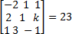 , A 1 B 2 C 3 D 4
- Find the matrix T if ST = I where S = and I is the identity matrix. ………
- Given that Q = , evaluate
- A matrix P = is such that PT = -P , where PT is the transpose of P . I f b = I, then P is.

THEORY

  - Find the inverse of the matrix 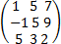
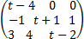
  - Find the values of t for which the determinant of the matrix below will give zero.

WEEK 5 DATE:
TOPIC: SIMULTANEOUS EQUATION (One linear, One quadratic) Examples
Solve simultaneously for x and y (i.e. the points of their intersection)

3x + y = 10
2x2 +y2 = 19
Note: One linear, One quadratic is only possible analytically using substitution method.

Solution.
3x + y = 10 eq 1
2x2+ y2 = 19 eq 2

Make y the subject in eq 1 (linear equation) y = 10 – 3x eq 3
Substitute eq 3 into eq 2

2x2 + (10-3x)2 = 19
2x²+ (10 – 3x) (10 – 3x) = 19
2x2 + 100 – 30x – 30x + 9x2 = 19
2x2 + 9x2 - 30x – 30x + 100 – 19 = 0
11x2 - 60x + 81 = 0
11x2 - 33x – 27x + 81= 0
11x (x-3) – 27 (x – 3) = 0
(11x – 27) (x – 3) = 0
11x – 27 = 0 or x-3 = 0
11x = 27 or x = 3
∴ x = 27/11 or 3
Substitute the values of x into eq 3.
When x = 3 y = 10 – 3(x)
y = 10 - 3(3)
y = 10 – 9 = 1

When x =27/11

y = 10 – 3(27/11) y = 10 - 51/11
y =110 - 51
11 y = 59/11

∴ w hen x = 3, y = 1

x = 27 , y = 59 11 11

EXAMPLE
Solve the equations simultaneously: 3x + 4y = 11 and xy = 2

solution

3x + 4y = 11 eq 1
x y = 2 eq 2
Make y the subject in eq 1 4y = 11 – 3x
y = 11 – 3x eq3
4
substitute eq 3 into eq 2 x y = 2

x ( 11- 3x )= 2
4
x (11-3x) = 2x4 11x – 3x2 = 8
-3x2 + 11x – 8 = 0
-3x2 + 3x + 8x – 8 = 0
-3x (x-1) +8 (x-1) = 0
(-3x + 8) (x-1) = 0
-3x + 8 = 0 or x – 1 = 0
3x = 8 or x = 1 x = 8/3 or 1
Substitute the values of x into eq 3 y = 11- 3x
4
when x = 1

y = 11 – 3(1)=11-3 = 8
4 4 2
y = 4 when x = 8/3

y = 11 – 3(8/3)
4
y = 33 – 24 = 9 = 3
12 12 4
∴ x = 1, y = 2
x = 8/3, y = 3/4.

Evaluation
Solve for x and y
I. 3x 2 - 4y = -1 II. 4x2 + 9y2 = 20 2x – y = 1 2x – 9y =-2

Reading Assignment NGM for SS IIEx 7d, 1 b, e, 2 b, c.

Simultaneous Equation (Further Examples)
Solve simultaneously for x and y. 3x – y = 3 eq 1
9x2 - y 2 = 45 eq 2
Solution

From eq 2
(3x)2 - y 2 = 45
(3x-y) (3x+y) = 45 eq 3
Substitute eq 1 into eq 3
3 (3x + y) = 45
3x + y = 15 eq4

Solve eq 1 and eq 4 simultaneously. 3x – y = 3 eq 1
3x + y = 15 eq 4
eq 1 + eq 4
6x = 18
x = 18/ 6 x = 3
Substitute x = 3 into eq 4. 3x + y = 15
3 (3) + y = 15
9 + y = 15
y = 15 – 9
y = 6
∴ x = 3, y = 6

Evaluation
- a. Given that : 4x2 – y2 = 15 b. Given that : 3x2 +5xy –y2 = 3
2x – y = 5 x - y = 4
Solve for x and y. solve for x and y.

WORD PROBLEM LEADING TO ONE LINEAR-ONE QUADRATIC EQUATION
Example:
The product of two numbers is 12. The sum of the larger number and twice the smaller number is 11. Find the two numbers.

Solution
Let x = the larger number y = the smaller number
Product, x y = 12 eq1
From the last statement,
x + 2y = 11 eq2
From eq2, x = 11 – 2y eq3
Sub. Into eq1
y(11 – 2y) = 12 11y – 2y2 = 12
2y2 -11y + 12 = 0
2y2 – 8y – 3y + 12 = 0
2y(y-4) – 3(y-4) = 0
(2y-3)(y-4) =0
2y-3 =0 or y-4 =0 2y = 3 or y = 4
y= 3/2 or 4
when y = 3/2 when y=4
x = 11 – 2y x = 11- 2y
x = 11 – 2(3/2) x = 11 – 2(4)
x = 11 – 3 x = 11 – 8
x = 8 x = 3
Therefore, (8 , 3/2)(3 , 4)

- Find a two digit number such that two times the tens digit is three less than thrice the unit digit and 4 times the number is 99 greater than the number obtained by reversing the digit.

Solution

Let the two digit number be ab, where a is the tens digit and b is the unit digit From the first statement,
2a + 3 = 3b
2a – 3b = -3 eq1
From the second statement,
4(10a + b) – 99 = 10b + a
40a + 4b – 99 = 10b + a
40a – a + 4b – 10b = 99
39a – 6b = 99
Dividing through by 3
13a – 2b = 33 eq2
Solving both equations simultaneously,
a = 3 , b = 3
Hence, the two digit number is 33

Reading Assignment
- New General Mathematics for SS 2 by J B Chamnon & Co page 73 – 78
- Past SSCE Questions
- Exam Focus (Mathematics).

Weekend Assignment
In each of the following pairs of equations solve simultaneously,
1. xy = -12 ; x – y = 7 a. (3 , -4)(4 ,-3) b. (-2 ,4)(-3, -4) c. (-4, 5)(-2 , 3) d(3 ,-3)(4,-4)
2. x – 5y = 5 ; x2 – 25y2 = 55 a (-8, 0)(3/5 , 0) b(0, 0)(-8 , 3/5) c (8 , 3/5) d (0, 8)(0, 3/5)
3. y = x2and y = x + 6 (a).(0,6) (3,9) (b)(-3,0) (2,4) (c)(-2,4) (3,9) (d).(-2, 3), (-3,2)
4. x – y = -3/2 ; 4x2 + 2xy – y2 = 11/4 : a(-1, 1/2)(1, 5/2).b.(3, 2/5)(1, 1/2)c.(3/2 , -1)(4,2) d.(-1 , -1/2)(-1 ,
5/2)
5. m2 + n2 = 25 ; 2m + n – 5 = 0 : a. (0,5)(4, -3) b.(5,0)(-3,4)c.(4,0)(-3,5) d(-5,3)(0,4)

Theory
1 a. Find the coordinate of the points where the line 2x – y = 5 meets the curve 3x2 – xy -4 =10
b. Solve the simultaneous equations: x + 2y = 5, 7(x2 +1) = y(x + 3y)
2. A woman is q years old while her son is p years old. The sum of their ages is equal to twice the difference of
their ages. The product of their ages is 675.
Write down the equations connecting their ages and solve the equations in order to find the ages of the woman and her son. (WAEC)

WEEK 6 Date:……...........

Topic

Surface Area and Volume of a Sphere, Hemisphere and Composite Shape Content
A solid in geometry is a shape with length, width, and height. It is not a flat shape. Some of the common solids are cuboid, cube, cylinder, cone, square based pyramids, sphere etc.
Below are sketches of common solids listed above.

Cuboid Cube

Cylinder Cone sphere

Sphere
Typical examples of sphere are football, oranges etc Area of a Sphere
r

Fig 4.2

Fig. 4.2 represents a solid sphere of radius r. Current surface area = 4πr2.
Volume of Sphere = 4πr3
3.
Example 1.
FIFA 2010 world cup ball(Jabulani) is made with a radius of 7cm. Find
  - the curved surface area of the ball
  - the volume (Take π= 22/7)
Solution
- Surface area = 4 πr2 r = 7cm
Surface area = 4 x ²²/7 x 7²
= 4 x 22 x 7 = 616 cm2
- Volume = 4/3 πr3
= 4/3 x 22/7 x 7 3/1
= 4 x 22 x 72= 1437.33cm3
3.

EVALUATION
- How many lead balls, each of radius 3cm, can be ,made from a lead sphere of radius 12cm?
- A student was asked to paint an earth globe of radius 21m.
- What is the surface area of the globe painted by the student?
- If the globe is filled up with the liquid paint, what is the volume of the paint used in filling the globe? (take π = 22/7)

Reading Assignment
  - New General Mathematics for SS3, chapter 3 pg 15-17
  - Essential Mathematics for SS3 by AJS Oluwasanmi Chapter 7 pages 86-87 Hemisphere
A solid hemisphere is half of a sphere.

( a ) (b)
Sphere Hemisphere = ½ of Sphere.
F,g 4.3
Area of hemisphere = ½ of area of sphere
= ½ x 4 πr2 = 2 πr2.
Volume of hemisphere
= ½ of sphere.
= ¹/⁷ x 4²/3πr³
= ²/3 πr³

Example 1:
Calculate the surface area and volume of a hemisphere which has a radius of 2cm(take π = 22/7) Solution:
Curved surface area of hemisphere = 2πr2
= 2 x 22 x 22

7

Volume of hemisphere = ²/3 πr³
= 2/3 x 22/7 x 23

= 25.14cm.

Example 2:
Calculate the total surface area of a solid hemisphere of radius 3.5m (take π = ²²/7) Total surface area = curved surface area + plane surface area
C.S.A. = 2πr² = 2 x ²²/7 x (⁷/2)²
= 22 x 7 = 77cm2
2
Plane surface area = πr² = ²²/7 x (⁷/2)²
20c
14cm
= 22/7 x 72 = 77/2cm2
22
Total surface area = (77 + 38.5)cm2 = 115.5cm2.

Example 3:
A solid shown below is made up of a cylinder with a hemisphere on top. Calculate
- the surface area b. the volume of the solid Total surface area = Area of hemisphere + area of cylinder Area of hemisphere = ½ ( 4 πr2) = 2πr2
= 2 x π x 72 = 98πcm2.
Area of cylinder πr2 + 2πrh
= π(7)2 + 2 x π x 7 x 20
= 49π + 280π
= 329 πcm2 total surface area = 329πcm2 + 98πcm2
= 427 π cm2
= 427 x 22 = 1342cm2
7

- Volume of solid = πr2h + ½ ( 4/3πr3)
= π x 72 x 20 + ²/3π x 73
= 980π + 686 π
3
= 3800cm3

Example 4
Fig. 2.3 shows a wooden structure in the form of a cone, mounted on a hemispherical base. The vertical height of the cone is 24cm and the base radius 7cm. Calculate, correct to 3 significant figures, the surface area of the structure (take π = ²²/7).
24cm
7cm
Solution:
Let the slant height of the cone be l . using Pythagoras rules: L2 = 242 + 72
L2 √625., L= 25cm
curved surface area of cone = πrl
= 22/7 x 7 x 25., = 550cm2
Surface area of hemisphere
= ½ x 4 πr2 = 2 πr2
= 2 x ²²/7 x 7²= 308cm².
Surface area of structure = (550+ 308) cm2, == 858cm2

Evaluation
- Calculate the total surface area of a solid hemisphere of radius 7.7cm. (Take π = 22/7)
- Calculate the volume and surface area of a hemisphere of diameter 9cm.

General Evaluation
- A hemisphere bowl has an external radius 0f 18cm and is made of wood 3cm thick. Calculate the volume of wood in the bowl.
- A measuring cylinder of radius 3cm contains water to a height of 49cm.If this water is poured into similar cylinder of radius 7cm, what will be the height of the water column
- From a cylindrical object of diameter 70cm and height 84cm, a right solid cone having its base as one of the circular ends of the cylinder and height 84cm is removed. Calculate
  - the volume of the remaining solid object expressing your answer in the form of a x 10n
  - the surface area of the remaining solid object.

Reading Assignment:
New General Mathematics, chapter 3, pages 16 -19.
Essential Mathematics for SS3, by AJS Oluwasanmi, chapter 7, pages 88 -90

Weekend Assignment
- What is the surface area of a sphere, radius 1cm to 3s.f.?
- Find the volume of a hemisphere of diameter 4cm (a) 16.8cm2(b) 16.8cm3 (c ) 15.8cm3 (d) 15.8cm2
- The volume of a sphere is 4190cm3. What is its radius? (a) 15cm (b)14cm (c) 12cm (d) 10cm.
- What is the diameter of a sphere of surface area 804cm2? (a) 18cm (b) 17cm (c) 19cm (d) 16cm
- What is the volume of a hemisphere of diameter 9cm?(a) 190cm3(b) 191cm3(c ) 192cm3 (d) 193cm3

THEORY
- A sphere has a volume of 1000cm3(a) Calculate its radius correct to 3.s.f.

(b) Find the surface area of the sphere.
- A hemisphere bowl has an external radius of 24cm and is made of wood 3cm thick calculate the volume of wood in the bowl.

WEEK 7 Date:……...........
Topic

SPHERICAL GEOMETRY
-The Earth Description
- Concept of Longitude and Latitude
- Concept of Great and Small Circles
- Radii and length of Latitude
Description of Earth: The earth is approximately spherical in shape. It has the North pole to the extreme on the upper part and the south pole to the extreme on the lower part . The poles are flat at the two extreme so that the shape is not circular.
The imaginary line (straight) through the centre running from the North pole to the South pole is called the axis of the earth. The equator is the largest imaginary circle that runs around the centre of the earth.

On the other hand, the radius of the sphere is not constant. The radius reduces from the equator towards the poles. The radius of the earth therefore changes from 6360km to 6380km and it is approximated to 6400km . Orange is another example of a sphere.

LATITUDE AND LONGITUDES
These are imaginary lines that run through the surfaces of the earth to locate position of a place on the earth’s surface. The horizontal plane through the centre of the earth and perpendicular to the axis of the earth forms a boundary line which is a circle. This circle is called a Great circle And this particular circle is the Equator. All great circles have radii equal to the radius of the earth, other examples of great circles are all lines of longitudes that run from the North pole to the South Pole, This great circle is called a meridian. The equator is a reference latitude while the inference longitude is the prime meridian.
Small circles are the lines of latitude that run from East to West except the equator. The lines of latitude are also referred to as parallel of latitude because they are parallel to each other. Half a meridian is a longitude.

The prime meridian is designated as longitude 0o since it is a reference longitude. Longitudes to the left of the prime meridian are said to be west of the prime meridian, while longitudes to the right are said to be East of the Prime Meridian.

Prime Meridian passes through the city of Tema in Ghana, and a place in London called Greenwich, and for this reason, it is sometimes called the Greenwich Meridian .

NGSK represents the prime Meridian. NBS, NFS, NHS and NQs are half a meridian.

LINES OF LATITUDE

Cross section view.
In fig 3(a) HBG is the equator, EAF is a parallel of latitude north of the Equator while ICJ is a parallel to latitude south of the Equator.
The minor arc AB from fig 3(b) subtends angle ADB = at the centre of the earth; and because of this, the point A is said to have a latitude xo north of the Equator. Similarly, the minor arc BC subtends angle COB = B at the centre of the Earth and because of this, the point O is said to have a
AOB = x AOC = B.

LINES OF LONGITUDES
In figure 4 (a) below NQS is the Prime Meridian, NPS is the longitude West of the Prime Meridian, while NRS is the longitude East of the Prime Meridian.

The Prime Meridian cuts the Equator at Q, the meridian NPS cuts the Equator at P while the Meridian NRS cuts the equator at R. O is the centre of the Earth.
From figure 4b , the minor arc PQ subtends angle POQ = θo at the centre of the circle. P is said to lie on the longitude θº, West of the prime meridian. Similarly, the minor arc RQ subtends angle ROQ = θº2 at the centre of the circle.
So, < POQ = θ <QOR = θ
The latitude and longitude of a place on the surface of the Earth are written as an ordered pair. For instance the city of Lagos in Nigeria is on (Latitude 6oN, longitude 3o E). this can be written as (6oN, 3oE).

Example 1
The city of Kumasi in Ghana is on latitude 6oN , longitude 10W ). Express in a shorter form. Solution.
Kumasi on (latitude 6oN,longitude 1oW) = K ( 6oN, 1oW)

Example 2.
Draw sketches to illustrate the positions of
  - Kinshasha on (16oS, 25oE )
  - Libya on (35oN, 42oW)
Solution
- Kinshasha ( 16oS, 25oE)

EVALUATION
  - G is the point where the Greenwich Meridian crosses the equator. Lines of latitude 70oN and 30oS and longitude 80oE and 40o W are given, make a sketch of the positions on the earth surface.
  - State the latitude and longitude of the following points.
(a) P (b) Q (c ) R (d) X (e ) Y (f ) Z

Reading Assignment:
New General Mathematics, chapter 7 pgs 52- 55.
Essential Mathematics for SS3, by AJS Oluwasanmi chapter 7, pgs 94-96

General Evaluation
X and Y are points on points on the Earth s surface at opposite ends of a diameter through the centre of the centre of the Earth.(a)If the longitude of X is 190E,what is the longitude of Y. (b)If the latitude of X is 520N,what is the latitude of Y?

Weekend Assignment
- The parallel of latitude is also referred to as …………………
  - horizontal of latitude, (b) verticals of latitude (c) lines of latitude (d) meridians.
- Which of the following is odd in the option below:
  - Equator (b) Prime meridian (c) latitude 0o (d) parallel of latitude
- The radius of an equator is equal to the radius of a prime meridian .
  - True (b) False (c) Neither false nor true (d) incomplete information.

Use this diagram for question 4 and 5.
- P is located on ………………………
(a) (45oN, 20oE) (b) (45oS, 20oW ) ( c) (45oN. 20oE ) (d) 45oS, 20oE).
- Q is located on ……………………
(a) (20oN, 200E ) (b) (30oN, 20oE) (c) (30oS, 20oE ) (d) 30oS, 20oW)

THEORY
- Make a rough sketch of a globe on your sketch, mark the following campuses of Good Shepherd Schools
  - Diligence Campus ( 600N, 550W) and . Wisdom campus ( 35oS, 55oW).
  - Peace campus (600N, 200E ) and Alakuko campus ( 350S, 200E).
- In the 18th century the length of ¼ of the earth’s circumference was taken to be 1000km. Use this value to calculate the radius of the earth to 3.s.f.

WEEK 8 Date: ……………………
Topic

ANGULAR DIFFERENCE
The angle subtended at the centre of the great or small circle by the minor arc joining two places on the great or small circle respectively, is called the angular difference between the two places. We shall consider the following:
  - differences in angles of longitude
  - differences in angles of latitude.

Differences in the angles of longitude
When the two points are located on the same side on the earth’s surface i.e. Either East-East or West –West, subtract the angles, otherwise, add them up.
Examples
- Abuja is located on 32o E while Lagos is on 15oE. What is the difference in their angles of longitude? (both lie on Lat. 60oN).
- Calabar is on 15oE of the meridian , while Lokoja is located on 120N, find the difference in their angles of longitude (both on latitude 40o S)
Solution

Difference in angle = 32o – 15o = 17o

Angular difference = 12 + 15 = 27o

Evaluation
- Ogun is located on 100W and Uyo on 50o W. Both lies on latitude 40oN. What is the angular difference?
- Find the angular difference between the following pairs of places on the Earth’s surface.
  - Ketu ( 32oS, 20oE) and Lekki ( 32oS, 65oE)
  - Gombe (20oN, 10oW) and Abuja (20oN, 45oE)

Differences in the angles of latitude
When two points are located on the same side along the same longitude on the earth’s surface i.e North-North, South-South, subtract the angles otherwise add them up.

Example: Find the angular difference between the following pairs of places on the Earth’s surface.
- Paris (35oN, 40oE) and Rome ( 25oS, 40oE)
- Oyo ( 80oS, 27oW) and Edo (47o S, 27oW).

Solution

Angular difference = 25 + 35 = 60o

Angular difference = 80 -47 = 33o

Evaluation
Find the angular difference between the following pairs of places on the Earth’s surface.
- P (30oS, 48oE) and Q ( 60oS, 48oE)
- R ( 22oS, 60oW) and S (38oN and 60oW)

DISTANCES ALONG THE GREAT CIRCLES
The great circles are only lines of longitude and equator which is 0o. Therefore distances along the lines of longitude will majorly be the focus. Their radii are the same as the radius of the earth ( R). The knowledge of mensuration shall be used to calculate the distance along the lines of longitude.

Distance along the great circle = Өo x 2πR (where R is the radius of the earth) 3600
Example 1
The position of Libreville (Gabon and Kampala (Uganda) to the nearest degree are (0oN, 90E) and (0oN,320E) respectively. Calculate their distance apart along the equator.

Solution
Step 1: Sketch a simple diagram of the earth and locate the position of Libreville and Kampala using the values given. (note that liens of latitude are positioned either closer to the North pole or South pole while the lines of longitude are positioned either to East or West of the Meridian.

The distance required is LK
Step 2: Find the difference between the angles of the longitude . Өo = <EOK - < EOL
:. Өo = 32 – 9o = 23o
Step 3: Calculate the distance LK ( are LK) using the mensuration formula to calculate the length of arc of a circle.
:. LK = Өo x 2πR (where R is the radius of the earth) 3600
= 23o x 2 x 22/7 x 6400 km 360o = 25.68km
= 2600km to 2 s.f.

Example 2:
An aeroplane from a town P (lat. 40oN, 38oE) o another town Q (lat.40oN,22oW) it later flies to a third town T (28oN,22oW) . Calculate the distance between Q and T. along the lines of longitude.
Solution
Step 1: Sketch a simple diagram showing the position of the points on the earth’s surface.

Step 2: Since Q and T lie on the same longitude (22oN) but different latitude ,calculate the difference in their angles of latitude using the same method as earlier done above i.e if the two latitude lie on North or South, subtract the angles, otherwise add them together .
Ө = <EOT = < EOQ
:. Diff = 40o – 28o = 12o Ө = 12o
Step 3: Calculate the distance QT along the line of longitude

QT = Өo x 2 πR 360o
= 1341 km = 1300km to s.f.

Example 3:
Chicago (USA) and Tokyo (Japan) both lie on longitude 25.9oE. their latitudes are 31.6oN and 24.8oS respectively Calculate the shortest distance between the towns.

From the figure above. <TOC = < TOE + <COE
<TOC = 31.6o + 24.8o = 56.
arc BG = 56.4 x 2 π R
360
= 56.4 x 2 x 22/7 x 6400
360
= 6270km to 3s.f.

EVALUATION
The position of Abuja (Nigeria ) and Bonn (Germany) to the nearest degree are (90N, 70E) and (510N,70E) respectively. Use R= 6400km, to calculate their distance apart to 2.s.f.

DISTANCES ALONG PARALLELS OF LATITUDE
Radius of a parallel of latitude . Consider the diagram sketched below:

Assuming points P and E are located on the longitude due East of the meridians as shown above. If O is the centre of the earth and C is the centre of the latitude of P. The angle of latitude of point P is θo. If r is the radius of the parallel of latitude through P, then on PCO.
CPO = θ (alternate <s CP//OE) OP = R (Radius of the Earth)
Cos α = ^{r}/Rr = R Cos α
The above relation is used to calculate the radius of any parallel l of latitude except equator.

Example1.
Find the distance measured along the parallel of latitude, between two points whose latitudes are both 56oN and whose longitudes are 23oE and 17oW respectively.

Solution
Sketch the diagram and locate the two points

Step 2: Since the distance needed is along the parallel of latitude, calculate the radius of the latitude r = R Cos α ( where α is the angle of the latitude)
r= 6400 x Cos 56o
Step 3: Calculate the difference in the angles of the longitudes. α = 230 + 17o = 40o
Step 4: Calculate the distance AB
arc = AB = Ө x 2πr where r = R Cos α
360
= Ө x 2πRCos α
360

= 40 x 2 x 22/7 x 6400 x Cos 56o
360
= 40,000 x 0.5592
9
= 2490km
Example 2
Two points M and N on the surface of the Earth are given by their latitudes and longitudes as M ( 50oS, 15oE) and N(50oS, 75oE) calculate :
  - the radius of the parallel of latitude on which M and N lie
  - the distance MN measured along the parallel of latitude (take R = 6400km) Solution
Step 1: Locate point M and N on a simple diagram

Step 2: Calculate the radius of latitude of the two points. r = R Cos θ
r = 6400km x Cos 50
Step 3: Go ahead and calculate the distance MN but firstly, we need to know the difference in the angles of longitude.
:.θ= 75o – 15o = 60o
:. MN = θ x 2πr 360
= 60º x 2 x ²²/7 x 6400 Cos 50 360
= 4740km , = 4740km to 2. sig.fig.

Example 3
R (lat 60oN, long 50oW) is a point on the earth’s surface. L is another point due east of K and the third point N is due south of K. the distance KL is 3520km and KN is 10951KM. Calculate
- the longitude of L b) the latitude of N. (take π = 22/7 and R = 6400Km)

Solution

Step 1: Sketch the diagram and try to locate the points.

Step 2: Calculate the radius of latitude K and L
R= R Cos Ө
r = 6400 x Cos 60o , r
Step 3: Find the difference in the two angles of longitudes K and L K = 50oN L is due east of K (Өo)
:. Diff = 50o + Ө
Step 4: since KL is 3520km, find the value of Өo KL = Өo + 50o x 2 x 22/7 x 6400 Cos 60o
360o
3520 = 50 + Өo x 22 x 6400
360 x 7
:. 50 + Өo = 63o Өo = 63 – 50o
:. Өo = 13o
<;L is 13oE.
To find the latitude of N:
Step 1: Find the difference between the angles of latitudes K and N. K = 60oN, N is due South of K
:. Diff = 60o + Өo
Step 2: Since the distance is along the great circle , there is no need to calculate the radius of the latitude.

KN = 60o + Өo x 2 πR 360o
10951 = 60o + Өox 2 x 22/7 x 6400
360
600 + Өo = 10951 x 2 x 22/7’ x 6400
44 x 6400
600 + Өo = 98o Өo = 98o – 60o
:. The latitude of N = 38oS.

Evaluation
1.A plane flies due East from A (lat. 530N, long 250E) to a point B (lat 530N, long. 850E) at an average speed of 400km/hr. the plane then flies due south from B to a point C, 2000km away. Calculate correct to the nearest whole number:
a. the distance between A and Bb. the time the plane takes to read point B c . the latitude of C (Take R = 6400km and π= 22/7)

Reading Assignment
New General Mathematics Chapter 7 pg 58-61,
Essential Mathematics for SS3, by AJS Oluwasanmi chapter 8 pgs 104-107

General Evaluation
- Find the distance between Bida (90N, 60E) and Addis Ababa (90N, 38.80E) measured along the parallel of latitude.
- Two places P and Q with longitudes of 1520E and 1710W both lie on the Equator.Find the shortest distance between P and Q on the Earth s surface.

- Two places P and Q have the same longitude. Their latitudes are 150N and 360S.Calculate the great circle distance between PQ.
- Two places X and Y on the equator are on longitude 670E and 1230E respectively. (a)What is the distance between them along the equator.
(b)How far is X from the North pole?(Take π = 22/7 and the radius of the earth as 6400km)

Reading Assignment:
NGM Chapter 7 pg 53-57
Essential Mathematics by AS. Oluwasanmi

Weekend Assignment
- The radius of Great Circles is approximately ……(a) 6500km (b) 6400km (c) 6500m (d) 6400m
- The circumference of a great circle with a radius of 6400km is approximately ……(a) 6200km (b) 6400km (c) 6300km 9d) 6100km
- P (440N, 100E) and Q (360S, 100E), what is the angular difference between point P and Q on the Earth’s surface?(a) 8o (b) 80o (c ) 70o (d) 20o
- What is the radius of parallel of latitude 300N?(a) 5530Km (b) 5540Km (c) 5440m (d) 5340Km
- What is the circumference of latitude 30o N ? (a) 34800km (b) 34900km (c) 35800km (d) 34700km

THEORY
  - Alakuko and Meiran lie on the equator on longitude 70E and 900W respectively, if the circumference of the earth is 4000km find their distance apart to 3s.f.

  - The position of A is 38oN, 73oE and the position of B is 38oN, 107oE. Calculate the distance from A to B
    - along the parallel of latitude (b ) along the great circle.

WEEK 9 Date: ……………………

Arithmetic of Finance:
- Simple Interest
- Compound Interest
- Annuities, Depreciation and Amortization

Simple Interest:
Interest: This is the amount paid on money borrowed. It is calculated as a percentage of the amount borrowed, at a particular rate and at a fixed period of time.
Hence; I = PRT 100
Where; I = Interest, P = Principal, R = Rate and T= Time (calculated annually)

Examples:
1. Find the simple interest on #6000 for 4 years at 9% per annum. Solution
I = PRT
100
I = 6000 x 4 x 9
100
= #2160
2. Find the amount if simple interest is paid on #150000 at 12% per annum for 3 years. Solution:
I = 150000 x 12 x 3
100
= #54000
Amount(A) = P + I = 150000 + 54000 A = 204000

Evaluation:
  - Abu saved #8000 with a cooperative society. If simple interest is paid at 4.5% per annum, find the amount which Abu has in the society at the of 4 years.
  - A woman has #80000 in the Term Savings account for 3 years. How much interest does she receive at the end of the 3 years if she makes no withdrawal for the whole period?

Compound Interest
If a sum of money is invested for n years at a particular rate per annum compound interest, the amount A, after n years is given by the formula:

A = P(1 + r/100)n
Example:
- Calculate the compound interest on #80000 for 2 years at 8.5% per annum.

Solution:
P = 80000, n = 2 years, r = 8.5% A = 80000(1 + 8.5/100)2
= 80000(1.085 x 1.085)
A = 94178
C.I = 94178 - 80000
= #14178
- A woman borrowed #500000 from a lender and pays interest at 12% per annum. If she repaid #100000 at the end of each year, what amount does she owe at the end of 2 years?
Solution:
P = 500000, r = 12%
Years 1: I = 500000 x 12 x 1
100
I = 60000
A = 500000 + 60000 = #560000
Repaid 100000, Amount = 560000 – 100000 = #460000
Year 2 : I = 460000 x 12 x 1
100
I = #55200
Amount remaining: 460000 + 55200 = #515200 - #100000 Total Amount = #415200

Evaluation:
- The sum of $180 is saved in an account which gives 9.5% per annum compound interest. Find the amount after 2 years, to the nearest cent.
- The sum of #100000 is invested at 6% per annum compound interest, the interest being added half yearly. Find the amount after 2 years.

Annuities, Depreciation and Amortization Example
- A refrigerator costs #55000. What is its cost at the end of 3 years if the annual rate of depreciation is 20%?
Solution:
1st year:
Value of refrigerator #55000 20% depreciation - 11000

2nd year:
44000
Value 44000

35200
20% depreciation 8800

3rd year:

Value 35200
20% depreciation 7040

28160

The cost at the end of the 3rd year is #28160.

- Find the amount of an annuity of #10000 paid yearly for 3 years at 8% per annum. Solution:
1st year annuity: #10000
Amount after 2nd year = 10000(1 + 0.08)2 = 10000 x 1.082 2nd year annuity after 1 year: 10000x 1.08
Total : 10000 + 10000 x 1.08 + 10000 x 1.082 = #32464

Amount of annuity: #32464

Evaluation:

- A television set costing #25000 depreciates by 15% in the first year and by 25% in the second year. Find its value after 2 years.
- How long will it take for prices to double if the rate of inflation is 25% per annum?

General Evaluation
- Using logarithm tables, find the compound interest on #20000 for 4 years at 12% per annum.
- Calculate the amount of an annuity of #20000 payable yearly for 5 years at 12% per annum.

Reading Assignment: NGM for SS 3 Chapter 5 page 35 – 42

Weekend Assignment
  - Calculate the amount if simple interest is paid yearly at 15% per annum for 4 years on a principal of #550000
  - Calculate the compound interest on #18000 for 10 years at 9.5% per annum.
  - Find the amount created by an annuity of #60000 payable yearly for 4 years at 4% interest.
  - A woman insures her life for #3million by paying a premium of #2000 at the beginning of each year for 20 years. After 20 years the insurance company ends the agreement and gives her a lump sum payment of #50000. Assume compound interest at 8% per annum.
    - Calculate the actual value of the premiums paid.
    - Find the profit made by the company.
    - Which piece of numerical information is not needed in this problem?

